## tracks table

## Fields

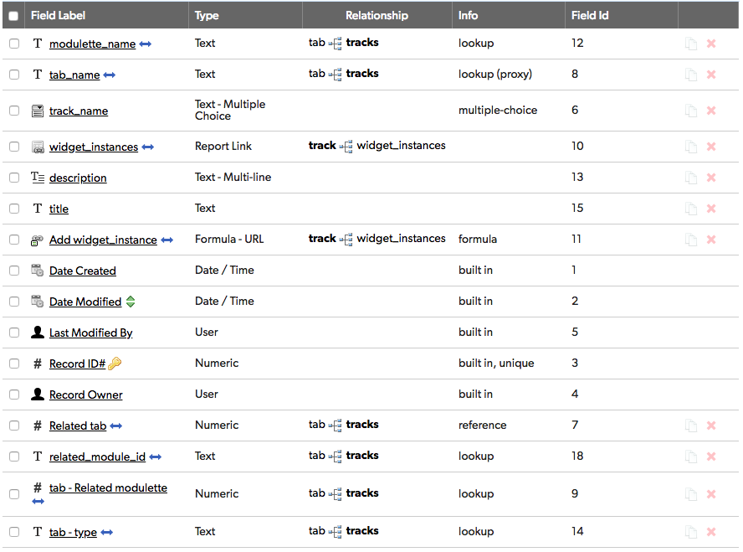

## Relationships

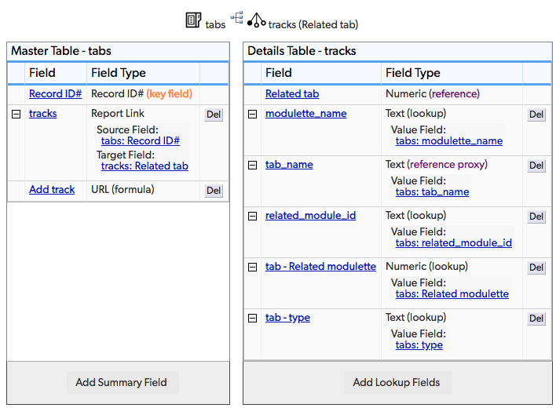

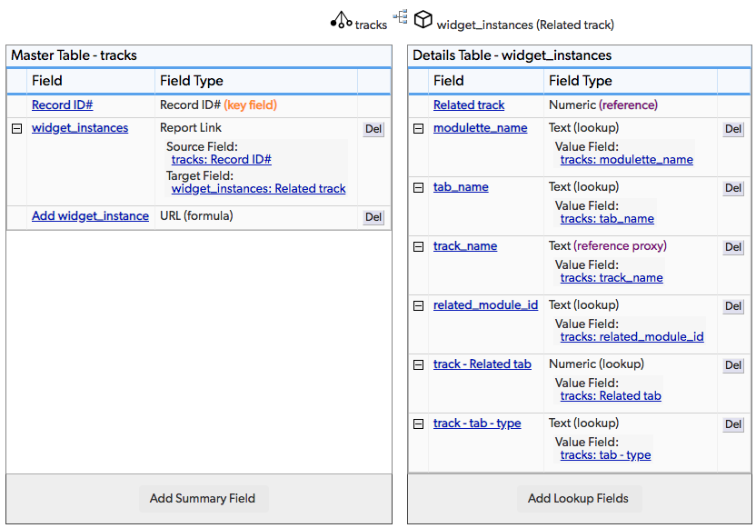

## Field settings

Note: Built-in fields use the default settings

modulette_name 4

tab_name 5

track_name 6

widget_instances 7

description 8

title 9

Add widget_instance 10

Related tab 11

related_module_id 13

tab - Related modulette 14

tab - type 15

# modulette_name

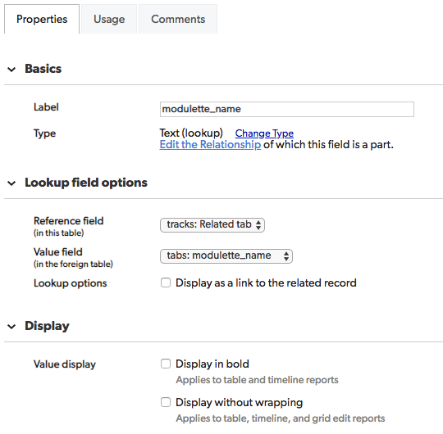

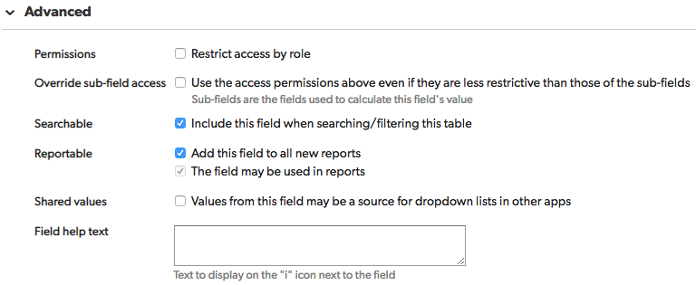

# tab_name

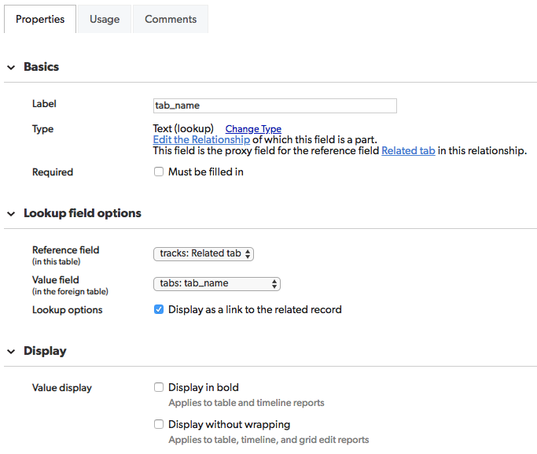

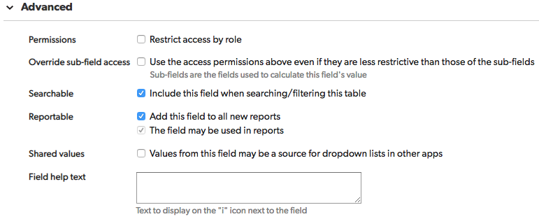

track_name  
 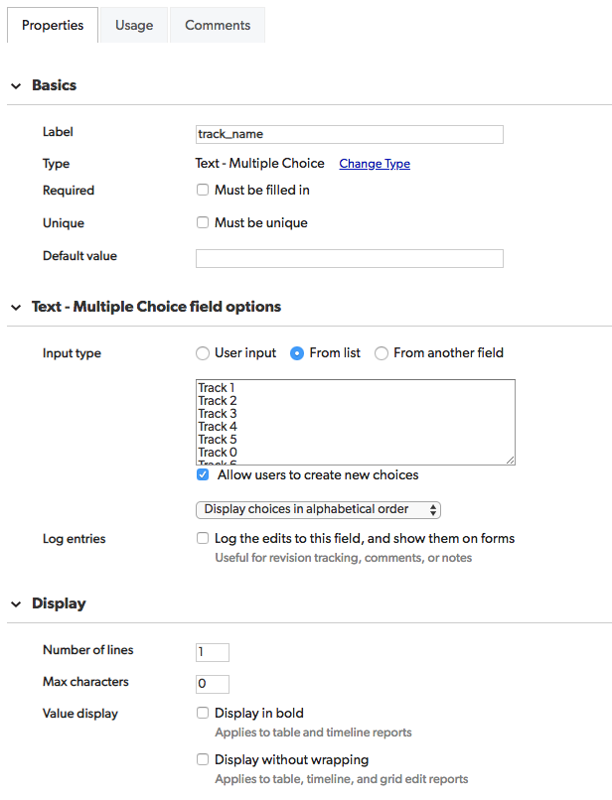

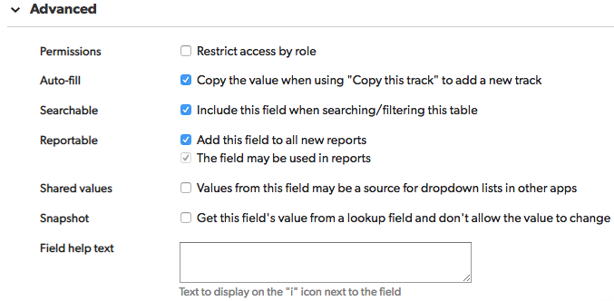

# widget_instances

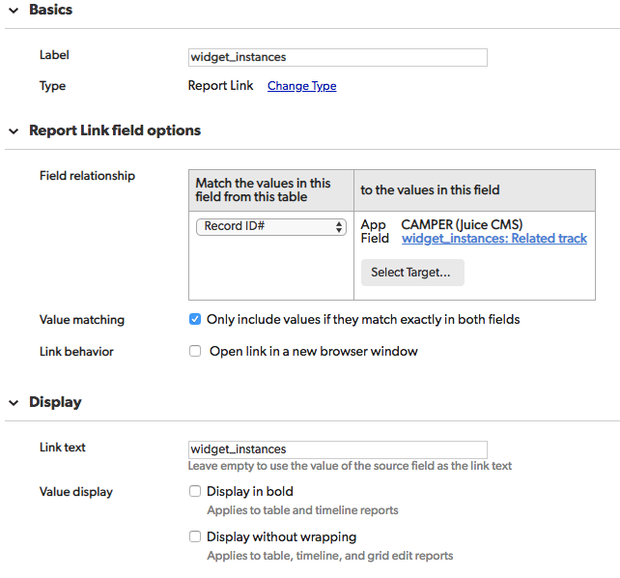  
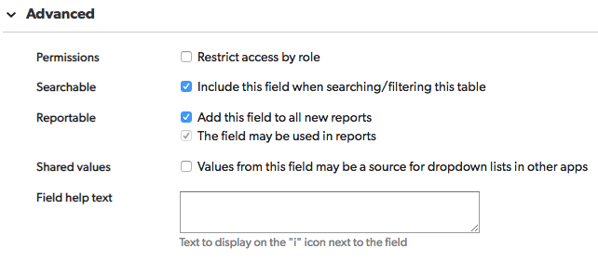

# description

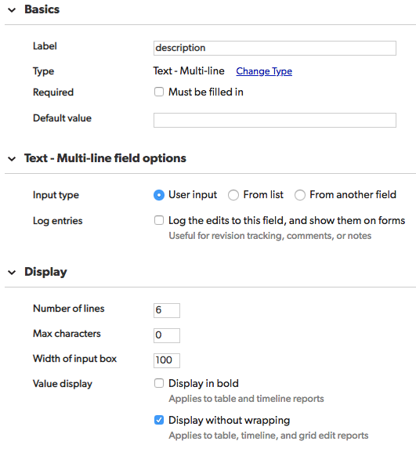

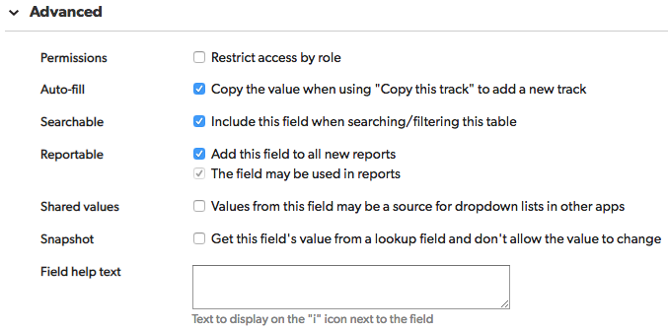

# title

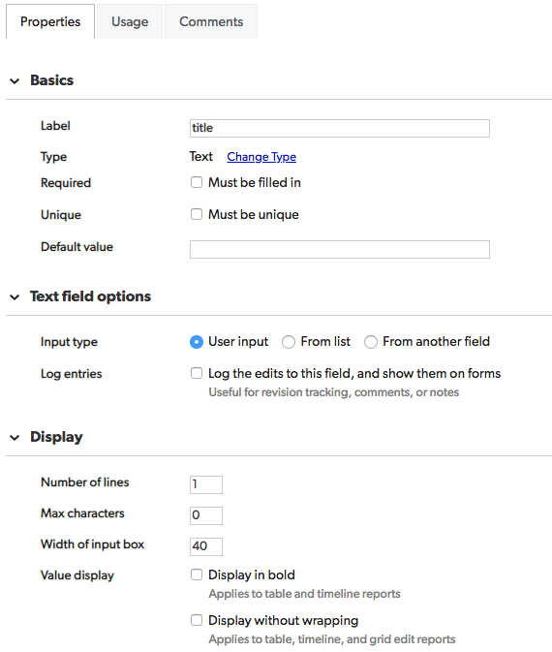

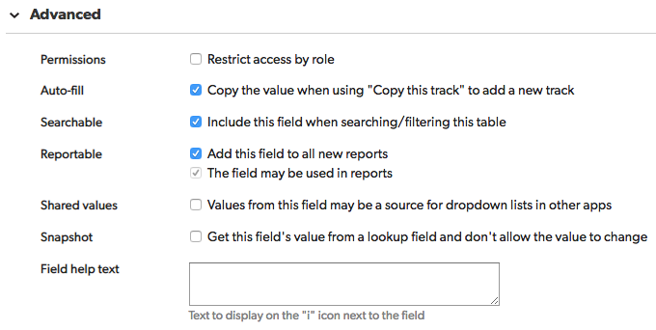

# Add widget_instance

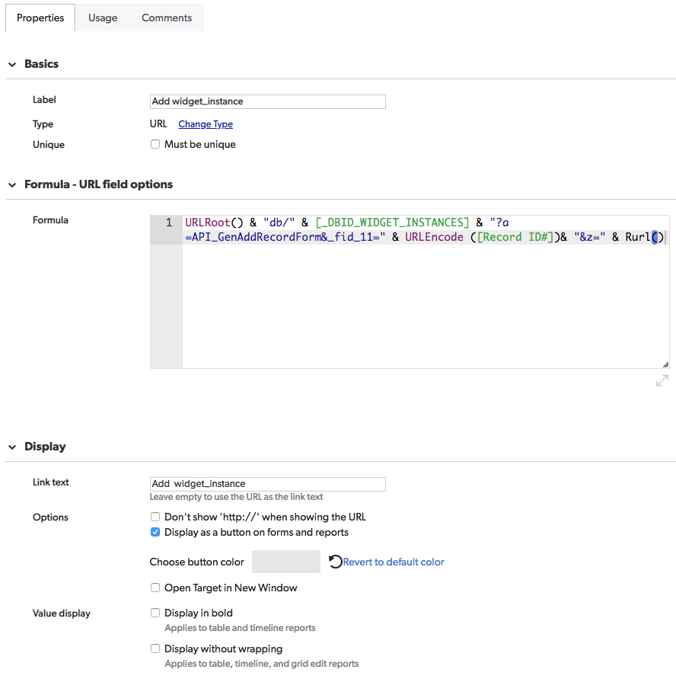

URLRoot() & "db/" & [_DBID_WIDGET_INSTANCES] & "?a=API_GenAddRecordForm&_fid_11=" & URLEncode ([Record ID#])& "&z=" & Rurl()

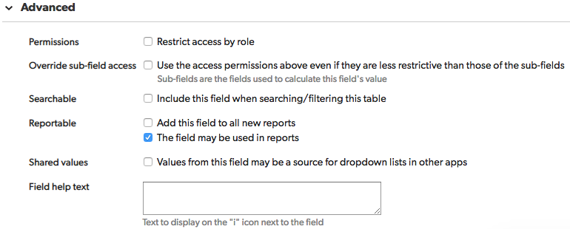

# Related tab

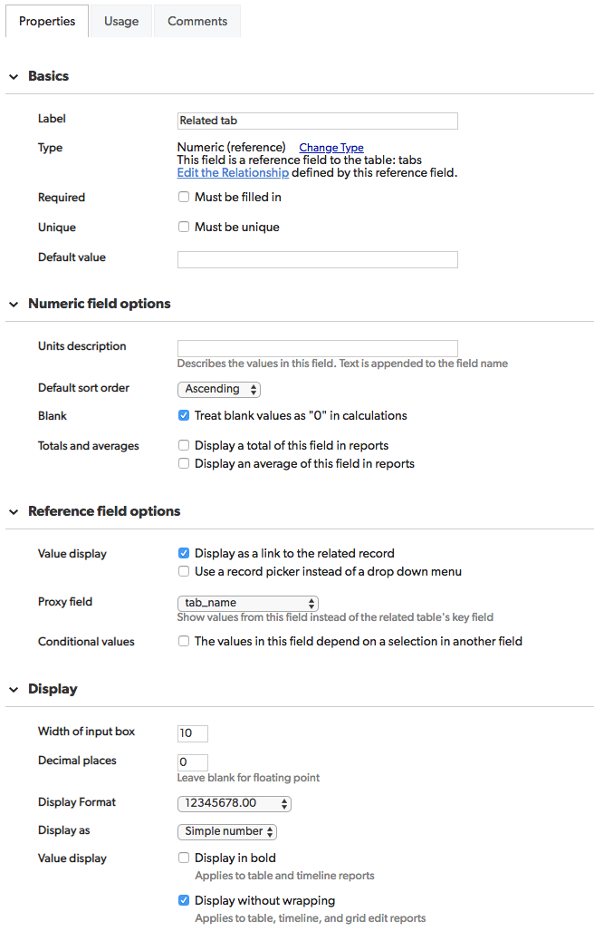

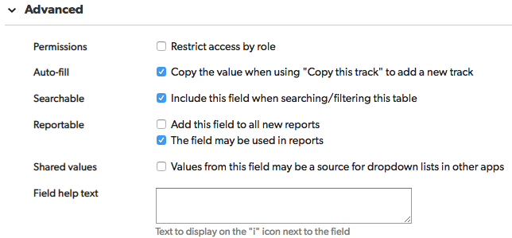

# related_module_id

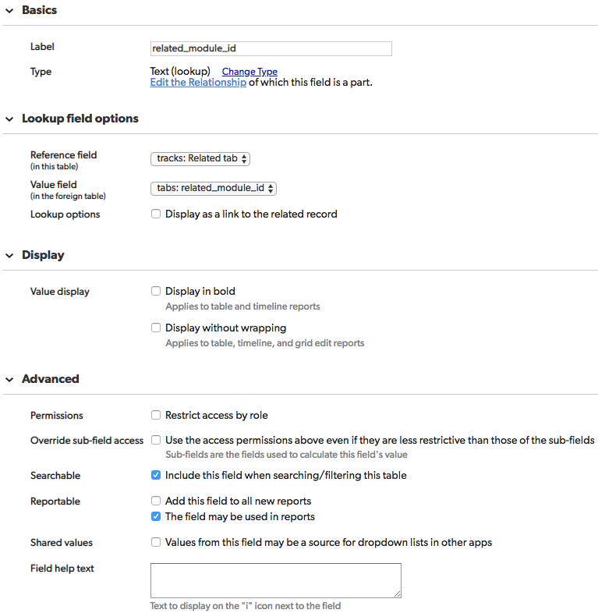

# tab - Related modulette

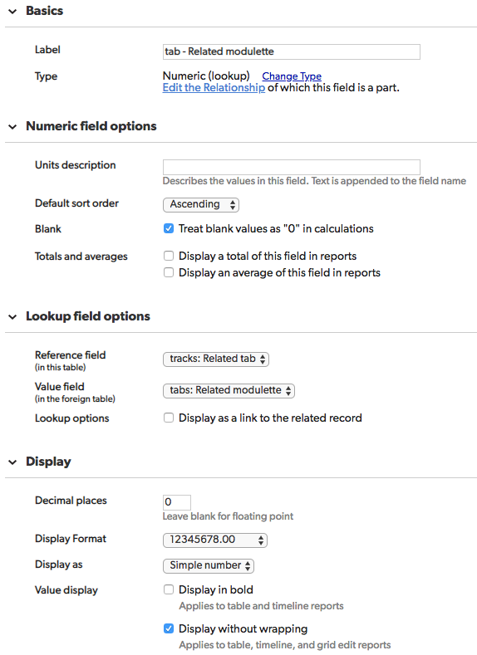

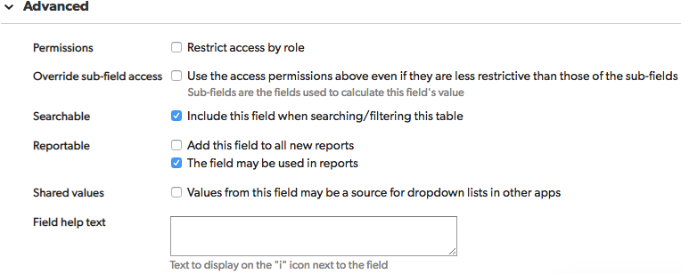

# tab - type

